Worksheet # 1
Common Agenda Worksheet
This worksheet will help your team get greater clarity about your issue. What does your gut tell you? Work your way around the six stages. At the end of the worksheet, you will find additional reflection questions for your team to consider when building your common agenda.
Definition of a Common Agenda: All participants have a shared vision for change including a common understanding of the problem and a joint approach to solving it through agreed upon actions.

Strategies  5 |  | Assumptions  6
Influential Factors  4 | Problem or Issue  1  Primary protective factor: |  | Desired results (outputs, outcomes and impact)  3
Community needs/assets /resources
2
Source: https://apps.publichealth.arizona.edu/CHWToolkit/PDFs/Logicmod/chapter3.pdf

Worksheet # 2
Designing Your Collaborative Approach: Measures & Mutually Reinforcing Activities
Think about your group’s common agenda, in addition to the overarching agenda to increase Family Well-being in the SKP. Picture the activities that enable a collaboration to be effective. Consider the following elements:
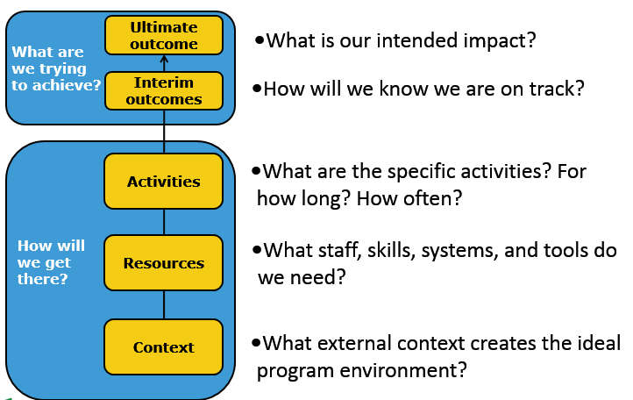

What are we trying to achieve? | Ultimate Outcome  What is our intended impact?  Interim Outcomes  How will we know we are on track?
How will we get there?  Program, networking, advocacy, engagement etc. | Activities  What are the specific activities that we will undertake?
 | Who leads each of these activities?
 | How long? How often?
 | For Whom?

Top 10 Community-level Shared Measures for Family Well-Being

# | Priority Measures for Family Protective Factors | Source | Can measure be tracked by workgroup? | Do efforts directly impact this measure?
Family Cohesion
1 | % of students who had at least one parent who talked with them about what they were doing in school about every day | YRBS
2 | % of children participating in developmental screening (ASQ) | ASQ
Networks & Social Support
3 | % of students who take part in organized after school, evening, or weekend activities one or more days during an average week | YRBS
4 | % of students who agree or strongly agree that in their community they feel like they matter to people | YRBS
Physical & Mental Health
5 | % of adults (aged 18 and older) who meet criteria for healthy weight (body mass index ≤ 25th percentile | BRFSS
6 | % of children above cutoff for social-emotional development | ASQ
Role Models
7 | % of students who feel comfortable seeking help from at least one adult besides their parents if they had an important question affecting their lives [FOCUS for collective impact] | YRBS
8 | % of students who agree or strongly agree that their teachers really care about them and give them a lot of encouragement | YRBS
Stability
9 | % of SKP households that pay less than 30% of monthly income on housing | ACS
10 | % of 18-24 year olds with high school diploma (or equivalency) or higher | ACS

ACS=American Community Survey
ASQ=Ages Stages Questionnaire
BRFSS=Behavioral Risk Factor Surveillance Survey
YRBS=Youth Risk Behavior Survey

Collective Impact Condition | Rating Criteria | Status  (1,2,3,4, or 5)  Pre-Assessment | More discussion from our group is needed on this condition  (yes or no) | More guidance from MAPP is needed on this condition  (yes or no) | Status  (1,2,3,4, or 5)  Post-Assessment
Common Agenda | 1 – In development  3 – On paper/revisiting/needs group buy-in  5 – All participants have a shared vision for change; joint approach established
Shared Measures | 1 – In development  3 – On paper/revisiting/needs group buy-in  5 – Data collected and results measured consistently; efforts remain aligned, holding participants accountable
Mutually Reinforcing Activities | 1 – In development  3 – On paper/revisiting/needs group buy-in  5 – Participant activities are differentiated and coordinated through a mutually reinforcing plan of action
Continuous Communication | 1 – In development  3 – On paper/revisiting/needs group buy-in  5 – Consistent, open communication exists to build trust, assure mutual objectives, and appreciate common motivation.
Backbone Support | 1 – In development  3 – On paper/revisiting/needs group buy-in  5 – A separate individual or organization with staff serves as the backbone for the entire initiative; coordinates participating organizations and agencies
Collective Impact Conditions - Rate and Reflect
Group Name:

